Linear Models:

Least Squared:

Probability:

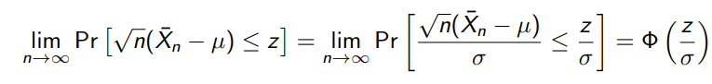

Linear Model:

Testing:

K-Groups (ANOVA):

Two-Sample t-tes:

Statistical power:

Bonferoni:

Contrast:

L1 Regularization:

Regularization:

CV:

Dealing with Heteroscadasticity:

Detecting Heteroscadasticity:

Permutation Test:

Least trimmed regression (80% smallest residuals example):

QQ Plot: